- IN CLASS ACTIVITIES FOR PRIMARY SCHOOLS

- My Puppets And I Speak English:
* Students make their own puppets and introduce their puppets to their friends.
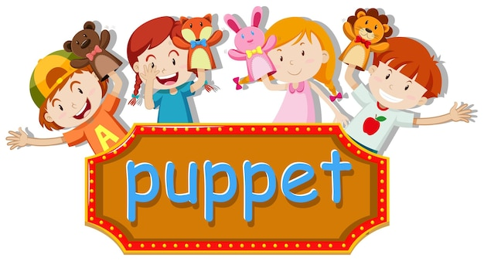
- Find The Missing Words Game:
* Teacher divides the students into two groups.
* He/She sticks some flashcards on the board or writes some vocabulary items which are in the unit.
* Teacher asks student to look at the words or cards for about two minutes to memorise the words.
* Then teacher tells the students to close their eyes and removes one of the words and wants students to find the missing word.

- Chain Words Game:
* Teacher says a sentence or a word -for example a class object- ‘ruler’ or a sentence ‘I have got a ruler.’
* Teacher asks one of the students ‘Student A’ to repeat what he/she said and to say another class object ‘ruler, pencil’ ‘I have got a ruler and a pencil.’
* And teacher asks ’Student B’ to repeat what they said and adds another word. ‘ruler, pencil, sharpener’ ‘I have got a ruler and a pencil and a sharpener.’

- Giving Instructions Game:
* Teacher says a word relavent to the unit ‘book’ and asks one of the student to say another word and the third student to give an instruction ‘sit down’ the rest of the students repeat the instruction and they carry out it.
* And the game goes on like this.
* Every third student gives an instruction and the rest of the class repeat and carry it out.

- Remember The Phone Number Game:
* Teacher divides the class into four groups and he/she writes four different phone numbers on the board.
* He/She gives the students one minute to memorise the numbers.
* Then teacher rubs out the numbers. He/She wants students to say the phone numbers.
- Drawing And Coloring Game:
* Teacher divides students into groups.
* One of the students in the group is ‘teller’ and the others are ‘listeners’.
* The teacher gives listeners a blank paper and teller a picture. For example: ‘The picture of school subjects in different numbers and different colours.
* The teller tells what he/she sees in the picture and the listeners draw and colour what the teller says.

- Say And Do ‘TPR’:
* First teacher gives an instruction or says some verbs and the students repeat them and act them out. Teacher says ‘walk’ students repeat the word ‘walk’ and pretend to walk.
* Later one of the students does an action and the rest of the students do it and say the word.

- Yes / No Game:
* Teacher draws a line down the middle of a space in the classroom or on the playground. Teacher tells the students that one side is YES, the other side is NO.
* Teacher asks students a question and tells them. If the answer is “Yes”, they pass or jump to yes side, If the answer is “No” they pass or jump to No side.
* After a while one of the students takes the role of the teacher and asks Yes/No questions to his/her friends. For example; ‘Do you run fast?’

- Find And Tell The Differences Between Pictures:
* Teacher divides the students into two groups.
*They give each group a picture. Pictures are similar but there are some differences between them.
* They tell what they see in their own pictures and find the differences between pictures. ‘My monster has got two black eyes.’ ‘My monster has got three green eyes.’

- Making Sentences Game:
* Teacher divides students into two groups and each group make a line in front of the board.
* Teacher writes or sticks some words and pictures on the board randomly.
* The first students in the line of each group make sentence by looking at the pictures and words on the board. The student who says a correct sentence first, gets the point.
- Act Out:
* Teacher shows some vocabulary items, verbs, adjectives or sentences in action.
* He/She plays a role. Students guess and tell what the teacher shows in action. And they repeat the words or sentence.
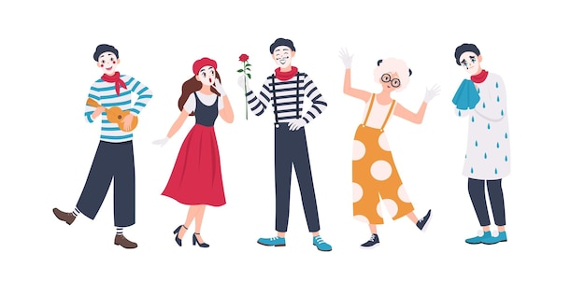

- Guessing Game:
* Teacher tells the game to the students.
* One of the students comes to the board. He/She gives some clues about the thing he/she thought. For example; he/she tought ‘a banana’. Student says a clue sentences. “It is yellow”
* The other students try to guess what it can be. “Is it a lemon?” The student can draw small part of the thing for a clue: draws ‘half banana’ or shows small part of a flashcard.

- Running Dictation:
* Teacher divides students into groups of four or five.
* In each group some of the students are reader and the rests are writer.
* Teacher writes some sentences on a piece of paper and hangs it on the wall or on the board.
* The reader runs and reads what is written on the paper and tells them to the other students. They write the sentences.

- Find The Missing Letters:
* Teacher writes a word and shows it one of the students. But he/she writes one letter missing intentionaly.
* The student spells the word loudly. The rest of the class write the letters and try to find the word and missing letter.

- Story Telling:
* Teacher gives some roles to the students and wants them to the perform their roles.

- CLIL:
* Content and Language Integrated Learning (CLIL) is an approach where students learn a subject and a second language at the same time. A science course, for example, can be taught to students in English and they will not only learn about science, but they will also gain relevant vocabulary and language skills. It’s important to note that CLIL is not a means of simplifying content or reteaching something students already know in a new language. CLIL courses should truly integrate the language and content in order to be successful – and success is determined when both the subject matter and language is learned.

Source: https://www.english.com/blog/content-and-language-integrated-learning/
A CLIL lesson plan sample: https://www.teachingenglish.org.uk/sites/teacheng/files/CLIL%20a%20lesson%20plan.pdf

- Video Dictionary:
* Teacher makes students group of three or four.
* He/She gives each group some vocabulary items relavant to the unit.
* Students prepare a presentation for every words by drawing pictures, writing example sentences, miming or acting out. And record this preparations to make a video dictionary.
* They present their videos in the class.

- Mime It Game:
* Teacher asks one of the students a question. ‘How are you?’ ‘How do you feel today?’
* The student doesn’t talk and mimes to answer. Rest of the class guess his/her answer and give some suggestions to him/her. ‘Are you bored?’ ‘Let’s watch a film.’

- Find Who?:
* Teacher chooses about ten students and wants them to come to the board.
* He/She gives each student a flashcard.
* The students says a sentence using this word in the flashcard about themselves. ‘I am bored’ and they give flascards to the teacher.
* Rest of the class listen and try to memorise what they said.
* After all the student say their sentence, the teacher asks questions about the students’ sentences. For example; “Who is bored?”
- Show And Tell:
* Teacher asks students to bring an object that is meaningful for them or an object which they like. For example; their toys
* And the teacher wants them to tell the objects “My toy’s name is …. It is big and round. It is pink. …” The other students can ask questions about the object.

- Colour It Game:
* Teacher divides the class in to two groups.
* There is a teller in each group. Teacher gives a picture to the teller. The teller tells what is there in the picture.
* The other students draw and colour the picture. The group which finishes first, gets the point.

- Drama:
* It is a kind of role play to perform and use something which is learned. Students can prepare their costumes.

- Pick A Word Say A Sentence:
* This game is played at the end of the lesson to revise the unit. Student says some sentences which they learned in the unit and teacher writes them on the board. ‘Can you turn off the light please?’ and then he/she writes some vocabulary items in the sentences on small pieces of papers and puts the papers in a box. ‘turn off’ ‘the light’
* Then teacher cleans the board and divides students into two groups.
* One student in each group comes and picks a paper in the box and tries to say a correct sentences. The group which says most correct sentences is the winner.

- Bingo:
* First student prepare ‘bingo cards’ ‘number bingo’.
* Students play Bingo game individually or in pairs. Teacher writes numbers or ‘words’ on pieces of paper then puts the papers in a bag.
* One of the students picks a paper and says the number ‘word’ in English. The other students which have bingo cards in their hands look their cards whether the number ‘word’ is in their cards or not. If the number which is picked and said in one students’ card, He/She takes the paper and covers the number in their cards.
* The student covering all the numbers in his/her card, wins the game.
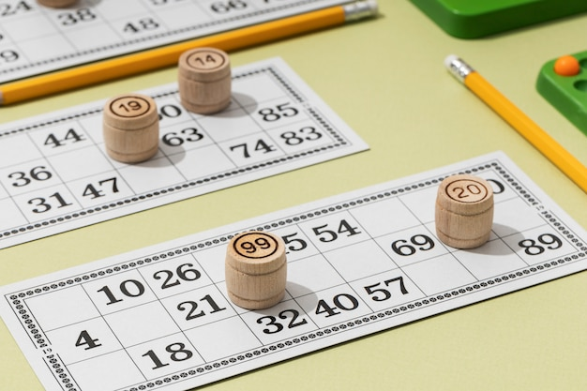

- Charades:
* Students says sentences or phrases which are in the unit and writes them on the board ‘get up, go to school, I have breakfast at eight o’clock.’ and teacher writes them on pieces of paper and puts them in a box.
* He/She divides students into groups.
* One of the students in the first group picks a paper from the box and tries to tell the sentence or pharse to the friends in his/her group without speaking. The students in his/her group try to guess the pharese or the sentence in a limited time.

- Prepare And Present An Experiment:
* Teacher wants students to make a research about an experiment.
* Students prepare an experiment. While they are doing it,they tell what is necessary for the experiment and what are the steps of the experiment.

- Taboo:
* Each student prepares a taboo card about the unit vocabulary. The first word /phrase is the secret word /phrase and there can be the picture of this word / phrase. Under this word/ phrase, there are some words related to the secret word. They bring these cards to the class and teacher collects the cards. The teacher divides the class into two groups.
* A student comes to the board and teacher gives him/her a card. The student tries to tell the word to the friends in his/her group without the using the taboo words on the card. And the other students in the group try to find the word in a limited time. The competition goes on by turn.

- Clothes Game:
* Teacher wants students to bring some clothes for the game.
* Teacher puts all the clothes in a big box. He/She shows all the clothes one by one. Student say the clothes’ names in English, and write them on the board.
* Then teacher divides students into groups of three or four. And chooses three students as jury. One of the jury members says a cloth with its colour and the first student in each group runs and tries to find it. The student who finds first, gets the point. When all the students in the groups are finished, they tell what they have in their hands. Jury counts the clothes and decides who is the winner.

- Who Is This Game?:
* Teacher wants students to bring some pictures of people.
* Teacher sticks the pictures on the board randomly. And one of the students describe a person in the pictures.
* The other students try to find which person is described in the picture.

- Find The Pair:
* Teacher stick some flashcard on the board randomly. There are some objects relevant to the unit in some cards and there are their English names in others. ‘bread – the picture of bread’
* Teacher turns all the cards back. And students try to find the pair. When one student finds the pair, he/she says a sentence using the word in the pairs. ‘I want some bread, because I am hungry.’ And he/she gets the point.

DIGITAL TOOLS FOR PRIMARY SCHOOL
- Canva:
Canva is a free graphic design platform that allows students and teachers to work with photo editing, design layout and templates, create invitations, lesson plans and more, all within an easy-to-use platform.
- Powtoon:
PowToon is an eTool that creates animated videos for personal, educational, or business/professional use. It is a free, web-based, user- friendly software that creates presentations via three simple and easy steps: writing a script, recording a voiceover, and adding visuals.
- Mentimeter:
Mentimeter is a cloud-based tool used to add interactivity to presentations using live questions, quizzes and polls to improve student engagement.
- Word art:
Word Art is an online word cloud art generator allows students and teachers to create amazing and unique word cloud art with ease
- Baamboozle:
Baamboozle is an online-based learning platform that uses games to teach. It offers a wide selection of games to get your students started right away.
- Chatter pix:
ChatterPix Kids lets teachers and students turn any image into a talking character with their voice recording added into a moving mouth animation.
- Renderforest:
Renderforest is a reliable cloud-based software solution that allows users to create a variety of intro videos, infographics, explainer animations as well as musical or other types of visualization in the fastest way possible.
- Wordwall:
Wordwall is a free online tool for creating learning activities. With this tool, teachers can enter the topic that they would like to cover in class into the Wordwall and receive a variety of ready-made, fully customisable activities such as quizzes, word games, maze chases and much more.
- Voki for education:
Voki is an application that allows you to create characters online and have these characters speak out the texts you type. Yes, the characters you create with Voki have the ability to voice texts written in many languages. In addition, with the difference between men and women in each language, it is also possible to vocalize with different accents of the language. Voki characters not only speak the text, they also have the ability to voice your voice recording and voice the voices you have recorded on your computer. With these features, Voki is a candidate to be a very entertaining tool for our lessons.

- IN CLASS ACTIVITIES FOR MIDDLE SCHOOLS
1. An Ice-Breaker Activity ‘Draw About Yourself’:
* Techer divides the class up into teams of about three or four students.
* Each student has a paper and he/she writes her/his name in the middle of the paper and then divides the paper into four parts.
* On the first part, the student draws his/her favourite food; on the second part, he/she draws the landmark of his/her hometown; on the third part the student writes a sentence about himself/herself; on the fourth part he/she writes a sentence about his/her family.
* After drawing and writing, one student asks questions about his/her paper and the other students in the group tries to guess the answers.
*With this activity students will know each other better and they have an opportunity to speak.

2. CLIL:
*Content and Language Integrated Learning (CLIL) is an approach where students learn a subject and a second language at the same time. A science course, for example, can be taught to students in English and they will not only learn about science, but they will also gain relevant vocabulary and language skills. It’s important to note that CLIL is not a means of simplifying content or reteaching something students already know in a new language. CLIL courses should truly integrate the language and content in order to be successful – and success is determined when both the subject matter and language is learned.
Source: https://www.english.com/blog/content-and-language-integrated-learning/
A Clil lesson plan example: https://www.teachingenglish.org.uk/sites/teacheng/files/CLIL%20a%20lesson%20plan.pdf

3. Preparing Models Of Buildings And Create A Neighbourhood In The School Garden:
* Each student makes a model of a building such as school, hospital, post office etc…
* They create a neighbourhood in the school garden or on the ground of classroom. One student asks “how can I go to the shopping mall?”. The other student looks at the model of neighbourhood and answers the question. The student who asks the question tries to go the shopping mall according to the answer.

4. Using The Models And ‘Show And Tell’:
* The models in the previous activity will be used again in this activity.
* Each student brings his/her model and try to describe his/her building to the class. The other students can ask questions about the model.
* You can use “Show and Tell” activity for other units.
* Teacher asks students to bring an object that is meaningful for them or an object which they like. This will encourge them to speak. Then he/she talk about the object
* The other students can ask questions about the object.

5. Paper Slide:
* Teacher divides the class up into teams of four students.
* In groups, each student has a duty. One student will be speaker, the other one will be illustrator, one will scriptwriter, the last one will be cameraman.
* The illustrator draws pictures about the content.
* The scriptwriter writes sentences about the pictures.
* The cameraman shoots the videos while the speaker is talking about the pictures.
* The speaker should slide the paper one by one while the cameraman is shooting the video.
* In the video, you can see only the paper and hear the voice.
* You can share this video on the Eba platform, school website.
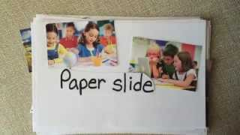

6. Hidden Words:
* Teacher writes some words in the small papers and prepares different topics.
* Teacher divides the class up into teams of four students
* Each student chooses a word and a topic. He/She shouldn’t show it to the other members of the group.
* The student makes up a story by using this word about the topic he/she chose. However, this word should be irrelevant to the story.
* The other members of the group try to find this irrelevant word.
* After they find the word, the other member chooses a word and topic and the activity goes on…

7- Snapwords or Figurative Notebook:
* Snapwords is the study of transferring English word meanings to paper with fun drawings. In this way, students' learning vocabulary becomes more permanent with the help of visual elements.
* Each student prepares a snapword for a word of the unit.
* They hang them onto bulletin board in the classroom or in the corridor of the school.
* The students try to guess the meaning of the words and talk about the words.
* Figurative notebook is used for a dictionary with pictures. Each student will have a figurative notebook about the words of the unit. And then they will describe it to the class.
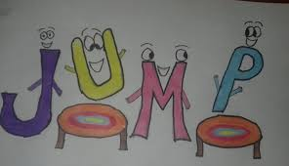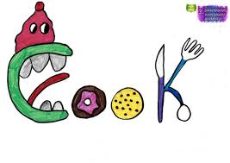

8. Running Dictation:
* Teacher writes some statements onto the paper and hangs it on the wall of the classroom. If teacher carries out this activity in the school garden, he/she hangs them on the trees or the walls in the garden.
* Teacher divides the class up into teams of about three or four students.
* Some students will be the reader and the others will be writer.
* The reader will read the statements and run towards the writer and the writer will write the statements on other paper.
* The faster group is the winner.

9. Video Dictionary:
* Teacher divides the class up into teams of about three or four students and has them watch the selected videos.
* Teacher should determine some target words from the video.
* Students work together and try to find a definition for the each word and then they make a new sentence by using this word.
* After one group finishes, the other group starts.

10. Taboo:
* Each student prepares a taboo card about the unit vocabulary. The first word /phrase is the secret word /phrase and there will be the picture of this word / phrase. Under this word/ phrase, there will be some words related to the secret word.
* They bring these cards to the class and teacher should collect them.
* Teacher divides the class into two groups.
* A student comes to the board and teacher must give him/her a card. The student tries to tell the word to his/her group without the using the words on the card. And the other students in the group try to find the word.
* The competition will go on by turn.

11. Creating A Story On Storyjumper And Vocalizing:
* Storyjumper is a popular tool for creating storybooks. It is easy to use for students of all ages and it can help them create their very own storybooks.
* Students can use their imagination and create new storybooks from scratch or customize pre-designed templates.
* Student can add their voice to the story.
* Creating a story digitally is free of costs but if you want to print it, the price can vary.

12. Ice Breaker Activity (Getting To Know You):
* Teacher uses dice to encourage conversation.
* Teacher gives everyone their own die and a list of questions associated with a number from one to six.
*Then, they roll, ask the question that matches the number and share their answers with each other.
* They choose to play as an entire small group or find a new partner after each question.

13. Finish The Sentence:
* Each student writes down half of a sentence on a piece of paper.
* Teacher collects all of the sentences and mixes them up in a bag or a bowl.
* He/She calls one student to the front of the classroom and has them draw a slip of paper.
* He/She gives the student a few seconds to prepare what they will say, and then has the student read the sentence aloud, complete it, and continue speaking on the topic for one minute.

14. Debates:
* Holding debates is a great way for students to speak a lot in class.
* Teacher acts as the facilitator or judge during the activity.
* He/She can announce the debate topic in advance or spontaneously, then divide students into “pros” and “cons” or “for” and “against” teams.
* One student says a statement about the topic and the other students can say “I agree / I disagree/ I think so/ I don’t think so etc…”

15. Two Truths One Lie:
* Each student should write three statements about themselves or the topic on a piece of paper.
* Two of them should be true, and one should be a lie.
* Students read their three statements, and their classmates question them to try to determine which statement is a lie.

16. Time Trials:
* Teacher gives the students a prompt and perhaps a few minutes to collect their thoughts.
* The prompt should allow for enough speaking to fill up four minutes.
* Once they are ready, put the students in pairs and have them take turns sharing their four-minute stories with each other.
* Teacher mixes up the pairs and have them take turns telling the same story, only this time they only have three minutes.
* Once both partners have retold their stories, teacher mixes up the groups one more time. They now only have two minutes to talk.
* Decreasing the amount of time they have to speak puts pressure on them to speak quickly while the repetition should allow for more rapid access to the language, i.e., increasing fluency.

17. Draw And Tell (Short Talks):
* Teacher creates a stack of topic cards for students, so that each student will have their own card.
* Each student draws their card, and then teacher assign them a time limit—this limit may be one minute initially, or maybe three minutes when they have had practice.
*This is the amount of time that they’ll have to speak about their given topic.
* Now, teacher gives the students a good chunk of time to gather their thoughts. Teacher may want to give them anywhere from five minutes to half an hour for this preparation stage. Teacher can let them write down three to five sentences on a flashcard to remind them of the direction they’ll take in the course of their talk.

18. Clock Activity:
* Teacher draws a clock on the board and writes a letter for each clock. For example; writes “-s” for one o’clock.
* Teacher says “It’s two o’clock”. The students look at the board and try to guess the word which is start with the letter.
s ……………
h…………
* After all words are found, students try to use them in sentences.

19. Gallery Walk:
* Teacher writes some sentences on paper and sticks them or some pictures on the different parts of the classroom.
* He/She groups the students and each group will go to the different paper and picture.
*Each group begins to talk about the statement or the pictures. And they write a common sentence of the group onto the paper or picture on the wall.
* Then the groups will change their parts and go to a different part and read the sentence of the previous group.
* If they agree with the sentence, they put a smiling face. If not, they draw a sad face.
* Each group has to go to the every part of the classroom and put a face to the sentences.

20. Alibi:
* Depending on the size of class, teacher picks several students as “Suspects.” The “Police” can work in groups of 2-4, and teacher needs one Suspect for each police group.
*So, for example, in a class of 20 teacher could choose four Suspects and then has four groups of four Police for questioning.
* The Suspects go outside or to another room to prepare their story. They need to decide all of the details about where they were during the time of the crime. For example: If they were at a restaurant, what did they eat? What did it cost? Who arrived first?
* The Police spends some time preparing their questions.
* The Suspects are called back in and go individually to each police group. They’re questioned for a few minutes, and then each one moves on to the next group.
* The Police decides whether their answers match enough for them to have a reasonable Alibi. (Maybe up to five mistakes is reasonable.)

21. Class Poll Activity:
* Teacher gets class conversations going by asking about students’ opinions on various topics that they can relate to.
* Learners undoubtedly will have a lot to say about recurring themes like culture, food, or lifestyle topics.
* Teacher can also spark a class discussion and survey based on a news story. For instance, he/she could interview students on how they maintain a healthy lifestyle during a pandemic or how their country is acting on climate change.
*Very young learners and beginners can focus on topics like favorite colors, family members, or pets.
* Meanwhile, instead of you asking the survey questions, why not let your students make the questionnaires and lead the discussions?

22. Pictionary:
* Each student draws a picture of word in the unit.
* Teacher hangs them on the bulletin board in the classroom or in the school corridors.
* The other student will come to the bulletin board and try to guess which words are they.
* If they find the word, they will use this word in a sentence.

23. True/False Storytelling:
* Teacher gives each student a piece of paper with either “true” or “false” written on it.
*Each student should tell the class a story that is true or false, depending on which word they received, and the class must guess whether it’s true.
*To add to the activity, teacher can allow the other students to question the student telling the story.

24- Ice Breaker Activity (Rainbow):
* The students writes their names on a paper.
* They draw a line from each letter of their name. Each line will be a different colour.
* They try to find an adjective or word of which the initial letter will be the letter of their names.

25. “I Have Never” Activity
* All students in the class should start this activity holding five fingers in the air (you can use less fingers to do this more quickly).
*The student who goes first tells the class one thing that they have never done.
*The students who have done that activity should put a finger down, and tell the class a story about this activity.
*A student is out of the game when all of their fingers are down.

26. Desert Island Activity:
* Teacher gives each student a piece of paper and tells them to draw an item—any item.
* He/She collects the drawings and passes them out again; no student should receive their own drawing.
*Next, she/he tells the students that they’ve been stranded on a desert island, and only half of the class can survive and continue to inhabit the island.
*The only thing each student will have on the island is the item depicted in the drawing given to them, and their goal is to convince the class that they should survive based on that item.
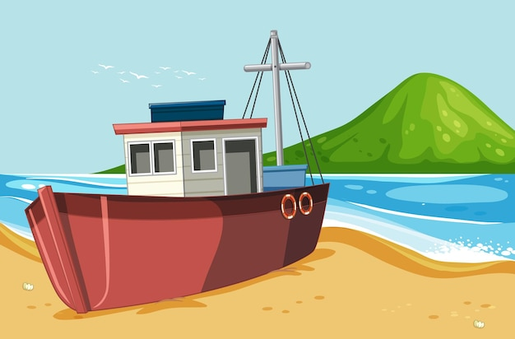

27. Who’s Telling The Truth:
* Teacher has each student write three facts about themselves that nobody in the class knows on a piece of paper.
* He/She makes sure each student includes their name on the top of the page.
* He/She collects the sheets of paper and brings three students to the front of the room.
* He/She reads aloud one of the facts that is true for one of these three students.
*All three claim that the fact is theirs, and the class then proceeds to question them in an attempt to determine who is telling the truth and who is lying.
*Each student is allowed to ask one question to one of the three students.
*After a round of questioning, the students guess who is telling the truth
Sources:
https://bridge.edu/tefl/blog/tefl-speaking-activities/
https://www.fluentu.com/blog/educator-english/esl-speaking-activities-for-adults/#toc_5
https://www.edutopia.org/discussion/12-fun-speaking-games-language-learners

DIGITAL TOOLS FOR MIDDLE SCHOOL
1. Voscreen:
Voscreen is a highly innovative way to help learners improve their English language skills on their own, without the express need for outside instruction. Moreover, it can also provide teachers the tools needed to develop their students' language skills in an engaging, interactive and challenging way. It’s easy and free.
Voscreen is an easy-to-use application that appeals to users who speak English from the first level to the advanced level. With the Voscreen application, you can increase your English predisposition by watching and hearing videos containing 15-second English conversations. You can also use this application to refresh your English knowledge. By selecting the English option in the Voscreen application, you can answer the questions in English using the same language options. Thus, users using the Voscreen application can access examples from more than one narrative style and have the opportunity to improve themselves in indirect speech.
Voscreen application has advanced scoring system. Because of this feature, many academic companies find it appropriate to use this application. It currently has over 1 million users in 104 countries. Among these users are many educational institutions. Educational institutions have included the Voscreen application in their curriculum.

2. Voki For Education:
Voki is an application that allows you to create characters online and have these characters speak out the texts you type. Yes, the characters you create with Voki have the ability to voice texts written in many languages. In addition, with the difference between men and women in each language, it is also possible to vocalize with different accents of the language. Voki characters not only speak the text, they also have the ability to voice your voice recording and voice the voices you have recorded on your computer. With these features, Voki is a candidate to be a very entertaining tool for our lessons.
Voki is a very convenient application especially for foreign language lessons. It offers a good opportunity to foreign language teachers with many language options. One of the biggest problems of students in foreign language lessons is speaking. Students are generally unable to put what they have learned into production because they are afraid of making mistakes or because they are ashamed. However, this type of students can voice a text they read with their own voice over Voki to another character. Thus, the pressure and fear on them will be reduced. In this way, our teachers can assign homework to their students who have the opportunity to use computers. Voki is a very convenient application to be used in foreign language courses as well as in other branches. Especially at the beginning of the lesson, a voice-over made with Voki can be used to attract the attention of the students. Or the voiceovers prepared over Voki can be used in the lessons with Voki presentations.

3. Lumi Education:
Lumi is a desktop application that allows you to create, edit, view and share interactive content with dozens of different content types. It is free and open source.

4. Powtoon:
PowToon is an eTool that creates animated videos for personal, educational, or business/professional use. It is a free, web-based, user- friendly software that creates presentations via three simple and easy steps: writing a script, recording a voiceover, and adding visuals.

5. Canva:
Canva is a free graphic design platform that allows students and teachers to work with photo editing, design layout and templates, create invitations, lesson plans and more, all within an easy-to-use platform.

6. Flipgrid:
Flipgrid is a popular video discussion platform. Flipgrid highlights passive learners and helps learners of all ages find their voices, share their voices, and respect the diverse voices of others. Flipgrid is 100% free for all educators, students and families.
Flipgrid app is an app that makes giving homework, measuring readiness level and getting feedback more efficient and enjoyable. With this application, you can ask your students to shoot a video explaining what they know about the subject before they study a subject, or as an evaluation after they have studied a subject, and you can help the whole class learn from each other through the videos they shoot.

3) IN CLASS ACTIVITIES FOR HIGH SCHOOLS
1. Show And Tell:
* Students bring photos about their environment or show them on the smartboard and describe it.
* They can use it also for their personal belongings. Each student brings an object to the class and tell something about it using possesive pronouns.
2. Flipgrid:
Flipgrid is an easy-to-use social learning, video making website that allows educators and students to make video clips. A teacher can create a grid or a series of grids that asks students to discuss topics or questions. The teacher can set the requirements of the responses to the subject, which could include time limits, attachments, video, pictures, and several other settings.
3. Baamboozle:
Baamboozle is an online-based learning platform that uses games to teach. It offers a wide selection of games to get your students started right away but you can also add your own. As a result, the library of content is growing daily as teachers add their own challenges to the resource pool.
4. Voscreen:
* Voscreen is a highly innovative way to help learners improve their English language skills on their own, without the express need for outside instruction. Moreover, it can also provide teachers the tools needed to develop their students' language skills in an engaging, interactive and challenging way. It’s easy and free.
* Voscreen is an easy-to-use application that appeals to users who speak English from the first level to the advanced level. With the Voscreen application, you can increase your English predisposition by watching and hearing videos containing 15-second English conversations. You can also use this application to refresh your English knowledge. By selecting the English option in the Voscreen application, you can answer the questions in English using the same language options. Thus, users using the Voscreen application can access examples from more than one narrative style and have the opportunity to improve themselves in indirect speech.

* Voscreen application has advanced scoring system. Because of this feature, many academic companies find it appropriate to use this application. It currently has over 1 million users in 104 countries. Among these users are many educational institutions. Educational institutions have included the Voscreen application in their curriculum.

5. Quizziz:
* Quizziz is an online tool that allows teachers to conduct student-paced formative assessments in a fun and engaging way for students of all ages. Teachers incorporate Quizizz into instruction, review, and evaluation to support students in Pre-K through College.
It’s super simple to learn and completely free to use! After providing students with a unique access code, a quiz can be recorded live as a timed competition or used as homework with a specific deadline. After the quizzes have been completed, students can review their answers.
* To play a game on Quizizz, you can either choose from a library of millions of public quizzes, or you can decide to create your own quiz! Once you have picked a quiz, you can conduct it in the classroom with Quizizz live mode or assign it as a homework game for students to practice at their own time.

6. Lumi:
It is an digital tool that makes learning accessible. Lumi is a desktop app that allows you to create, edit, view and share interactive content with dozens of different content types. It's free and open source.Teachers want students to prepare videos according to the topic that they are learning.Then, after uploading the video to this platform thay can add any types of questions.Meanwhile they can evaluate the topic in an enjoyable way.It also enables permanent learning and also student-centered learning that make students to active at every stage of lesson.

7. Role Play:
* Teacher divides class into groups and wants them prepare a very brief dialogue and then acts it out. A dialogue, skit, or play gives students context. Learning, memorizing, and practicing a drama allows students to interact with the content on a deeper level, engaging all four language skills: reading, speaking, listening, and writing (if they also make their own props for the stage, or if they take notes on their lines, for example).
* Teaching language through drama gives students an opportunity to relax the mind while learning and retain knowledge better.
* Memorization of lines activates and trains the brain while connecting language with gestures.
* Acting helps students remember words and sentences.
8. Taboo:
* Each student prepares a taboo card about the unit vocabulary. The first word /phrase is the secret word /phrase and there can be the picture of this word / phrase. Under this word/ phrase, there are some words related to the secret word.
* They bring these cards to the class and teacher collects the cards.
* The teacher divides the class into two groups.
* A student comes to the board and teacher gives him/her a card. The student tries to tell the word to the friends in his/her group without the using the taboo words on the card. And the other students in the group try to find the word in a limited time.
* The competition goes on by turn.

9. Toontastic:
The Toontastic allows students to create an animation in which they move characters and provide the audio to narrate / explain their animation. The results is an animated cartoon in which their characters speak, and the combination of moving characters and audio recordings often results in a well crafted product. Toontastic takes students through the setup to create an interesting and compelling cartoon. The app will start with the "Setup" and explain what each part of the cartoon needs to make it a complete story. For example, when you get to the conflict, the app tells you to create a problem for your character. The layout for the cartoon creation is that of a narrative.

10. Running Dictation:
* Teacher writes some statements onto the paper and hangs it on the wall of the classroom. If teacher carries out this activity in the school garden, he/ she hangs them on the trees or the walls in the garden.
* Teacher divides the class up into teams of about three or four students.
* Some students will be the reader and the others will be writer.
* The reader will read the statements and run towards the writer and the writer will write the statements on other paper.
* The faster group is the winner.

11. Paper Slide:
It is a fun and creative way for students to present information on paper through a video. Students can record their “story” using a digital video camera, ipad or a mobile phone. This template can be a "guide" for young students who are beginning to make paper slides.

12. CLIL:
Content and Language Integrated Learning (CLIL) is an approach where students learn a subject and a second language at the same time. A science course, for example, can be taught to students in English and they will not only learn about science, but they will also gain relevant vocabulary and language skills. It’s important to note that CLIL is not a means of simplifying content or reteaching something students already know in a new language. CLIL courses should truly integrate the language and content in order to be successful – and success is determined when both the subject matter and language is learned.
Source: https://www.english.com/blog/content-and-language-integrated-learning/
A CLIL lesson plan example: https://www.teachingenglish.org.uk/sites/teacheng/files/CLIL%20a%20lesson%20plan.pdf

13. Canva:
Canva is a free graphic design platform that allows students and teachers to work with photo editing, design layout and templates, create invitations, lesson plans and more, all within an easy-to-use platform.

